Legacy Real Estate System — Technical Design Document
Prepared 18/10/2026 by Brian · Based on the SRS dated 17 October 2026

1. Overview
This document describes how the Legacy Real Estate platform will be built. The SRS (17 October 2026) says what the system must do; this document says how: components, data, flows, interfaces and the infrastructure behind them. It is the reference for the developer, the QA team and anyone who takes over the codebase later.
Scope. The scope is version 1 as defined in SRS §1.2: the back-office web app, the landlord, tenant and buyer portals, the public listings website, M-Pesa and bank integrations, notifications, accounting and reports. Out of scope: full general-ledger replacement, payroll and smart-meter hardware.
Source documents
Document | Purpose
System Requirements Specification, 17 Oct 2026 | Functional and non-functional requirements (§1–§18)
User Stories backlog, 18 Oct 2026 | 176 stories (LR-1.01 to LR-13.20) with acceptance criteria
packages/contracts/openapi.yaml | API contract, the source of truth for every endpoint (to be written)
Design principles
- Money is never lost or doubled. Every inbound payment is stored before it is processed, every job is idempotent, and every money operation runs in one database transaction on the primary.
- Nothing financial is deleted. Corrections are reversals, credit notes or new effective-dated rows, so history can always be rebuilt.
- Partners never block users. SMS, M-Pesa, banks and KRA are reached only through queues, never inside a web request.
- Settings, not code. Tax rates, penalty rules, reminder schedules, templates and permissions are data an admin can change.
- Branch isolation on the server. Every query is scoped by the user’s branches; hiding data in the UI alone doesn’t count.
- Easy to hand over. Mainstream tools, one monorepo owned by Legacy, contract-first API and documented runbooks.

2. System architecture
The platform is one Laravel codebase deployed as four workloads, plus a separate Next.js website, on Kubernetes. Users and Safaricom reach it through a single load balancer; everything slow or external runs in background workers.
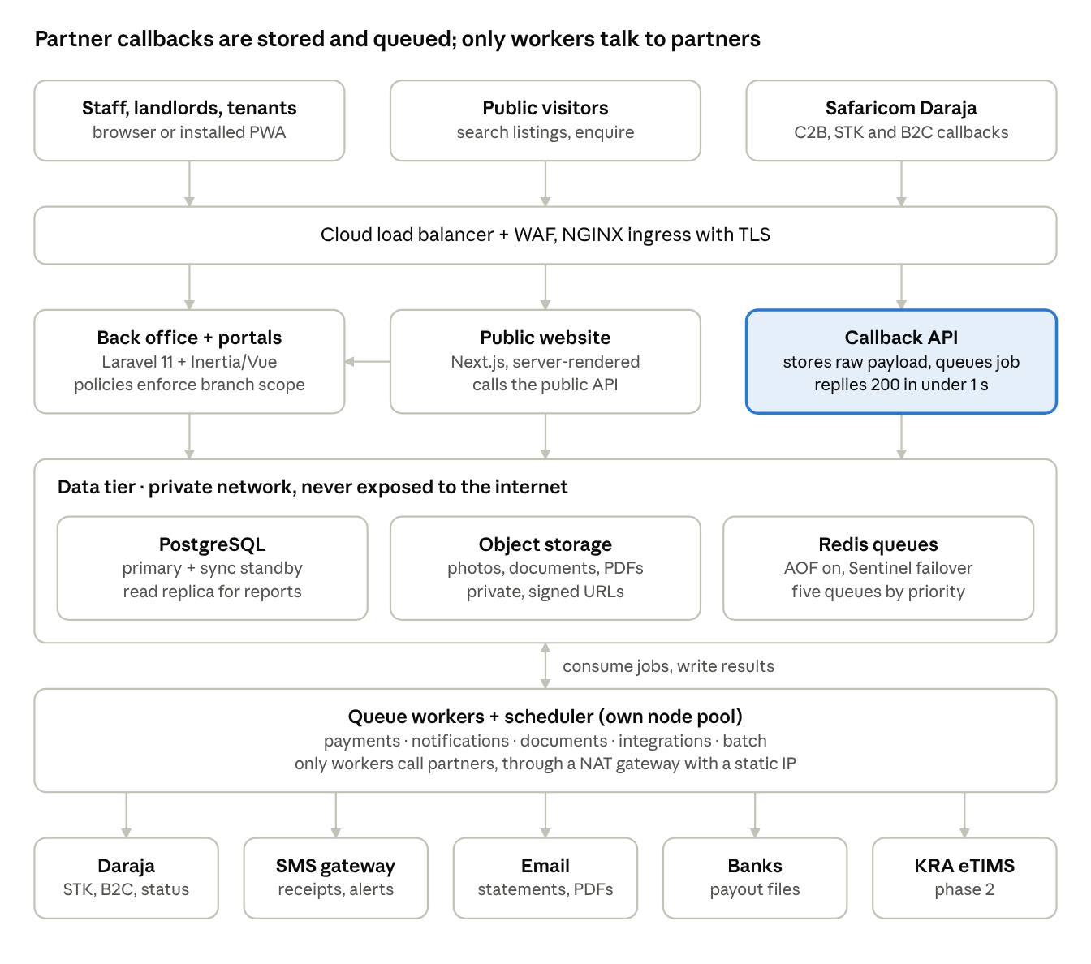
System architecture · 4 tiers, 5 outbound partners
Read top to bottom: requests enter through the ingress, the three front workloads read and write the data tier, and workers take jobs from Redis and make every outbound call. The callback API is highlighted because it is the one path where losing a request means losing money, so it does nothing but store and queue.

3. Technology stack
The stack below uses the first-choice option from SRS §16 at each layer. The SRS allows Django + Celery in place of Laravel; if the developer chooses it, the rest of this design still holds (Celery replaces Horizon, Schemathesis replaces Spectator).
Layer | Choice | Why
Backend | Laravel 11 (PHP 8.3) | Widely known in Kenya; mature Daraja libraries; built-in queues, scheduler, policies
Database | PostgreSQL 16 | Foreign keys, transactions, row-level locking, partial unique indexes, mature HA operators
Back office + portals | Inertia.js + Vue 3 + Tailwind | One app and one auth session; server-side routing keeps permission checks in Laravel
Public website | Next.js (server-rendered) | SEO-friendly URLs and cached pages; reads listings through the public API
Mobile | Progressive Web App | Installable on low-end Android, works on slow connections; no app-store release cycle
Queues | Redis 7 + Laravel Queues + Horizon | Priorities, retries, dashboard; AOF persistence on
Object storage | S3-compatible (MinIO in dev) | Photos, documents, generated PDFs; versioning on in production
PDF generation | Browsershot (headless Chromium) or DomPDF | Server-side templates for invoices, receipts, statements, agreements
API contract | OpenAPI 3.1, Spectral, oasdiff, openapi-typescript + openapi-fetch | Contract-first, typed client, breaking changes caught in CI
Containers | Docker images, Helm charts, Argo CD | Same charts on k3s (dev), staging and managed Kubernetes (production)
Infrastructure as code | Terraform + Ansible (k3s dev node) | Repeatable environments
Monitoring | Sentry, Prometheus, Grafana, Loki, Alertmanager | Errors, metrics, logs, queue-depth alerts

4. Application modules
apps/core is one Laravel codebase (a modular monolith) split into domain modules under app/Domain/<Module>. A module exposes services and events; other modules never write to its tables directly. One codebase runs as four entry points: web (back office and portals), callback-api (partner callbacks only), worker (queue consumers) and scheduler.
Module | Owns (tables) | Main responsibilities | Talks to
Identity & Access | users, roles, permissions, branch_user, audit_logs | Login, 2FA, roles, branch scoping, approvals inbox, audit log | Every module (policies)
Properties | properties, blocks, units, unit_charges, rent_rates | Properties, units, codes, bulk create, rent review, vacancy board | Tenancies, Website
Landlords | landlords, management_agreements | KYC, agreements, commission rules, expense thresholds | Accounting
Tenancies | tenants, tenancies, checklists, notices | Reservation, onboarding, renewals, transfers, move-out, deposit refund | Billing, Properties
Billing | invoices, invoice_lines, credit_notes, meter_readings, penalties | Invoice runs, water billing, penalties, credit notes, arrears ageing | Payments, Notifications
Payments | mpesa_transactions, bank_statement_lines, payments, payment_allocations, tenant_credits | Callback intake, matching, Unmatched queue, allocation, reconciliation | Billing, Accounting, Notifications
Land Sales | land_projects, plots, buyers, plot_sales, instalments, transfer_steps | Pipeline, payment plans, defaults, due diligence, commissions | Payments, Notifications
Maintenance | tickets, vendors, inspections, expenses | Ticket workflow, landlord approval, vendor payments, recurring expenses | Accounting, Landlords
Accounting | accounts, journal_entries, journal_lines, remittances, tax_settings | Double-entry posting, remittance runs, MRI, VAT, exports | Payments, Landlords
Notifications | messages, templates, opt_outs | SMS, email, WhatsApp; templates; delivery reports; bulk sends | All modules (via events)
CRM & Website | leads, viewings, listings | Leads, viewings, match engine, public listing feed | Properties, Land Sales
Reporting | (read-only views) | Dashboards and reports on the read replica | All (read only)
Platform | failed_jobs, settings, documents, imports | Settings, file storage, imports, failed-jobs screen | All
Rules between modules
- Cross-module effects go through domain events (e.g. PaymentAllocated, TenancyActivated, InvoiceIssued), with listeners queued after commit.
- Money-changing services (allocation, invoice run, remittance) live only in Billing, Payments and Accounting, and each has unit tests for every rule (SRS §18.1).
- Reporting reads from the replica only; no module calls Reporting.

5. Data model
The schema keeps the entity names and relationships in SRS §15. Every business table carries branch_id (directly or through its parent), created_by, created_at and updated_at.

5.1 Conventions
- Primary keys: bigint identity internally; a public uuid column exposed in URLs and the API, so IDs can’t be guessed.
- Money: bigint in cents (KES × 100). Never floats. Totals are computed in SQL or a Money value object.
- Dates: timestamptz stored in UTC, shown in Africa/Nairobi. Billing periods are date (first day of the month).
- Effective dating: rent_rates, unit_charges and tax_settings carry effective_from and nullable effective_to. An exclusion constraint stops overlapping periods for the same unit and charge type.
- No deletes on money: invoices, payments, allocations, journal entries and remittances have no delete path. Database roles for the app have no DELETE grant on these tables.
- Encrypted fields: national_id, kra_pin and bank account numbers use Laravel encrypted casts (AES-256-GCM, key in the secrets manager). A separate *_hash column (HMAC) allows exact-match search and duplicate checks.
- Phones: stored as 2547XXXXXXXX / 2541XXXXXXXX, validated on input.

5.2 Core entities
Entity | Key columns | Constraints and relationships
branches | name, town | Nairobi, Nakuru; has many paybills
paybills | shortcode, purpose (rent / land / landlord), branch_id | Unique shortcode
users | name, phone, email, password_hash, totp_secret | Many-to-many roles and branches
landlords | type, name, national_id (enc), kra_pin (enc), payout_method, bank fields (enc), mpesa_phone | Has many management_agreements
management_agreements | landlord_id, property_id, commission_type, commission_rate, fixed_fee, letting_fee_rule, deposit_holder, expense_threshold, payout_day, mri_enabled, start, end | One active agreement per landlord and property
properties | branch_id, name, type, county, area, gps, amenities (jsonb), house_rules | Has many units
units | property_id, code, type, bedrooms, status, water_meter_no, kplc_no, listed | code unique, case-insensitive (citext)
rent_rates / unit_charges | unit_id, charge_type, amount, effective_from, effective_to | No overlapping periods
tenants | type, name, national_id (enc), kra_pin (enc), phone, language, flagged | national_id_hash indexed for duplicates and blacklist
tenancies | tenant_id, unit_id, type (residential / business), start, end, due_day, grace_days, notice_days, status | At most one active tenancy per unit (partial unique index)
invoices | tenancy_id or plot_sale_id, branch_id, number, period, status, total | Unique (branch_id, number); unique (tenancy_id, period) for monthly runs
invoice_lines | invoice_id, charge_type, description, amount | Sum equals invoice total
mpesa_transactions | trans_id, type, shortcode, amount, msisdn, bill_ref, payer_name, trans_time, raw (jsonb), status | trans_id unique: the duplicate guard
payments | channel, reference, amount, payer_phone, tenancy_id or plot_sale_id, status | Unique (channel, reference)
payment_allocations | payment_id, invoice_line_id, amount | Sum of allocations ≤ payment amount
tenant_credits | tenancy_id, amount, source_payment_id | Overpayments, applied to the next invoice
deposit_entries | tenancy_id, type (held / top-up / deducted / refunded), amount | Separate ledger; never income
land_projects / plots | project: mother_title, vendor; plot: code, lr_no, size, use, cash_price, instalment_price, status | plots.code unique
buyers / plot_sales / instalments | sale: price, deposit_pct, plan_months, forfeiture_pct; instalment: due_date, amount, status | One active sale per plot
transfer_steps | plot_sale_id, step, status, done_on, responsible_user_id, document_id | One row per checklist step
tickets / vendors / expenses | ticket: category, priority, status, cost, chargeable_to; expense: property_id, amount, approval_status | Expense links to ticket when it came from one
remittances | landlord_id, period, gross, commission, expenses, tax, net, status | Unique (landlord_id, period)
accounts / journal_entries / journal_lines | line: account_id, debit, credit, source_type, source_id | Deferred constraint: debits = credits per entry
messages / templates | channel, template_key, recipient, status, provider_ref | Logged against any party (polymorphic)
approvals | subject_type, subject_id, action, maker_id, checker_id, status, reason | checker_id <> maker_id (check constraint)
documents | owner_type, owner_id, type, path, uploaded_by | Polymorphic attachment
audit_logs | user_id, action, entity, entity_id, old (jsonb), new (jsonb), ip, at | Append-only; app role has INSERT and SELECT only

5.3 Money rules enforced in the database
- Invoice numbers come from a per-branch counter row updated with SELECT … FOR UPDATE in the same transaction as the invoice, so there are no gaps (story LR-5.05). PostgreSQL sequences are not used for this because they skip numbers on rollback.
- Journal entries must balance (deferred constraint trigger).
- Allocations can’t exceed the payment or the invoice line (trigger checks both sums).

6. State machines
Status changes are made only by a model’s state machine service, never by setting the column directly, so each transition can check its guard, write an audit entry and raise an event. Any transition not listed is rejected with HTTP 409. The tables below are the implementation reference; QA can turn each row into a test.

6.1 Unit
From | To | Trigger | Guard
Vacant | Reserved | Reservation created | Unit listed as lettable
Reserved | Vacant | Reservation expires or is cancelled | Scheduler checks expiry daily
Reserved | Occupied | Move-in invoice fully paid | Signed agreement and ID uploaded; or manager override with reason
Occupied | Notice Given | Tenant gives notice | Exit date ≥ notice date + notice period
Notice Given | Vacant | Tenancy closed after move-out | Deposit refund approved
Any except Occupied | Under Maintenance / Unavailable | Manual | Reason required
Under Maintenance / Unavailable | Vacant | Manual | —

6.2 Tenancy
Pending (reserved, awaiting move-in payment) → Active (move-in invoice paid) → Notice (notice recorded) → Ended (exit inspection done, final bills raised) → Closed (deposit refunded or balance written to arrears). A transfer ends one tenancy and opens another, carrying balance and credit.

6.3 Plot
From | To | Trigger
Available | Reserved | Booking fee paid
Reserved | Available | Reservation expires
Reserved / Available | Sold – Paying | Deposit paid on a signed sale
Sold – Paying | Sold – Fully Paid | Final instalment allocated
Sold – Paying | Cancelled → Available | N missed instalments; cancellation approved; refund less forfeiture paid
Sold – Fully Paid | Title Processing | First transfer step started
Title Processing | Title Issued | New title registered
Title Issued | Closed | Collection form uploaded

6.4 Maintenance ticket
Open → Assigned → Quotation → (Awaiting Landlord Approval, only when cost > agreement threshold) → In Progress → Completed → Closed. A landlord rejection returns the ticket to Quotation. Closed requires the tenant’s confirmation or the auto-close timeout (to confirm, see §16).

6.5 M-Pesa transaction
Status | Meaning
received | Raw callback stored; job queued
duplicate | trans_id already seen; nothing else happens
matched | Account reference resolved to a unit or plot; payment created
unmatched | No match; waiting in the Unmatched queue with suggestions
allocated | Payment allocated to invoice lines (and any credit)
reversed | Reversed by an accountant with a reason; linked reversal payment

6.6 Approval (maker-checker)
Pending → Approved (action runs in the same transaction) or Rejected (reason required). The checker must differ from the maker and hold the approval permission for that branch. Used for refunds, waivers, payouts, rent changes, remittance runs, write-offs and land cancellations.

7. M-Pesa payment processing
A C2B payment goes from tenant to SMS receipt in under a minute. The callback API only stores and queues; matching, allocation and the receipt all happen in the payments worker.
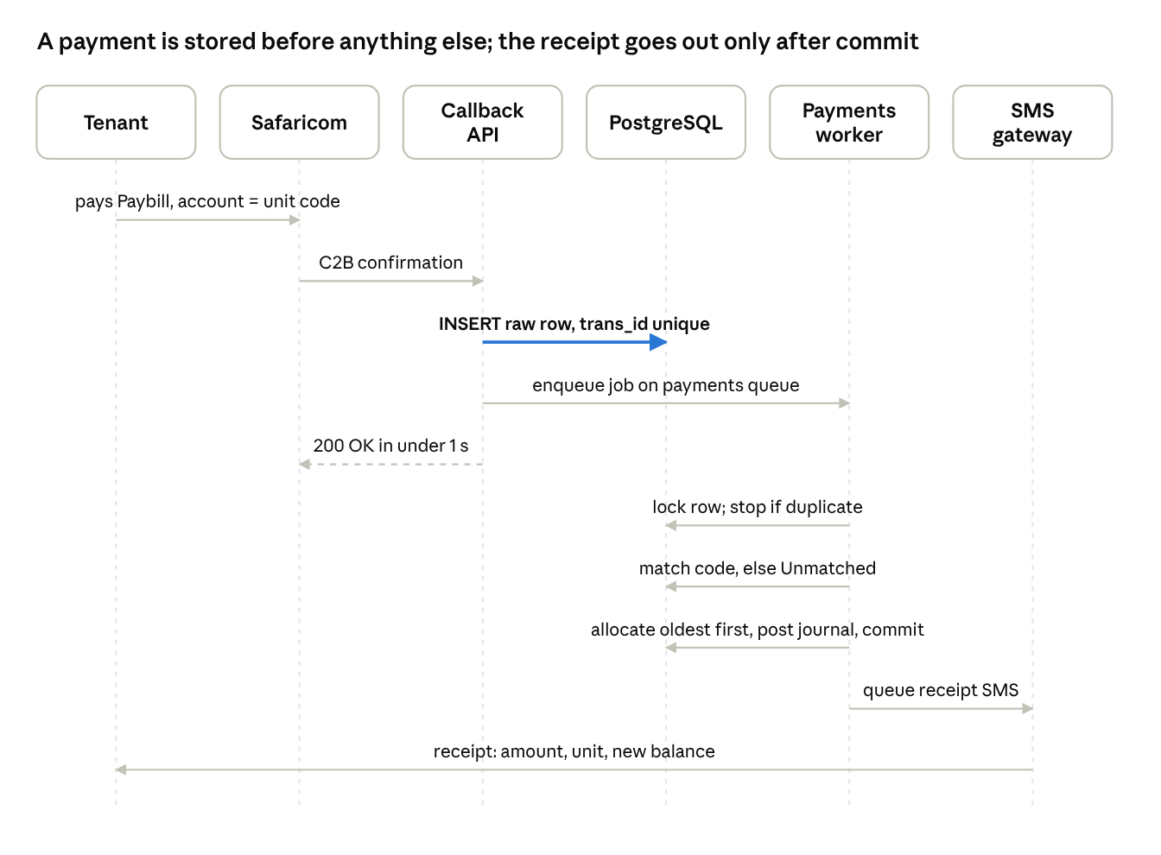
M-Pesa C2B payment sequence · 6 participants, 10 steps
The highlighted step is the guarantee: once the raw row is in PostgreSQL, the payment can’t be lost, even if Redis, the worker or the SMS gateway fails afterwards (the sweeper in §9 re-queues it).

7.1 Matching algorithm
The worker resolves BillRefNumber to a unit or plot in this order, stopping at the first hit:
- Normalise: uppercase, trim, remove spaces and the characters - _ / ., so “nrb khc b04” and “NRB-KHC-B04” both become NRBKHCB04.
- Exact code: compare against normalised units.code and plots.code for the Paybill’s branch or purpose.
- Phone reference: if the reference looks like a phone number, normalise it to 254… and look up an active tenant or buyer with that phone.
- No auto-match beyond this. Anything else goes to the Unmatched queue with up to three suggestions, ranked by: payer MSISDN matches an active tenant or buyer; trigram similarity (pg_trgm) between the reference and unit codes or short forms such as “B4” within properties the payer is linked to; amount equal to a tenant’s open balance.
An accountant picks a suggestion or searches; allocation then runs exactly as below and the receipt is sent.

7.2 Allocation algorithm
Runs in one database transaction on the primary, holding SELECT … FOR UPDATE on the tenancy’s open invoice lines:
- Load open invoice lines for the tenancy, oldest invoice first, then by the configured charge order (default: penalties, utilities, rent, other).
- Apply the payment to each line until it is used up; write a payment_allocations row per line touched.
- Mark fully paid lines and invoices paid, part-paid ones partially_paid.
- Put any remainder in tenant_credits; it is applied automatically when the next invoice is issued.
- Post the journal: Dr M-Pesa clearing, Cr tenant receivable (and Cr tenant credit for any remainder).
- Fire PaymentAllocated and commit; listeners queue the receipt SMS and PDF, and update unit status if this cleared a move-in invoice.

7.3 Other channels
- STK Push: the portal or SMS link calls POST /invoices/{id}/stk-push; the stored CheckoutRequestID ties the result callback to that invoice, so matching is skipped and allocation starts at that invoice.
- Bank statements: each uploaded line is matched by reference using the same normalise-and-match rules; unmatched lines join the same Unmatched queue.
- Cash and cheque: entered manually by permitted users, then allocated the same way. Cheques allocate only when marked cleared.
- Land instalments: the same pipeline with plot codes; allocation goes to the oldest due instalment, and the final instalment triggers the Sold – Fully Paid transition.

8. API design
The API is contract-first: packages/contracts/openapi.yaml is written and merged before an endpoint is built, and the typed client and mocks are generated from it (SRS §17.8).

8.1 Conventions
- Base path: /api/v1. Breaking changes need a version bump; fields are deprecated for at least one release before removal.
- Auth: session cookie for the Inertia back office and portals (Laravel Sanctum, SPA mode); bearer tokens for the Next.js website’s server and any future mobile app. 2FA is enforced at login for finance roles.
- IDs: public UUIDs only. Money fields are integer cents with a currency: "KES" field.
- Pagination: cursor-based, ?cursor=…&limit=50 (max 200), response {data, next_cursor}.
- Filtering: ?filter[branch]=nrb&filter[status]=occupied&sort=-created_at.
- Idempotency: every POST that creates money (payments, allocations, refunds, payouts) requires an Idempotency-Key header; a repeat returns the first result.
- Errors: RFC 9457 problem JSON: {type, title, status, detail, errors}. 403 for scope violations, 409 for invalid state transitions, 422 for validation.
- Lint: Spectral rules enforce naming (snake_case fields, plural nouns), pagination and error shape.

8.2 Key endpoints
Area | Endpoint | Notes
Units | GET /units, POST /properties/{id}/units:bulk | Vacancy board filters; bulk create with preview
Rent review | POST /rent-reviews | Creates an approval; applies on effective date
Tenancies | POST /tenancies, POST /tenancies/{id}/notice, POST /tenancies/{id}/move-out | Each step a state transition
Deposit refund | GET /tenancies/{id}/deposit-refund (calculation), POST …/deposit-refund | POST creates an approval
Invoices | GET /tenancies/{id}/invoices, POST /invoices/{id}/credit-notes | Invoices themselves are never PATCHed
Statement | GET /tenancies/{id}/statement | JSON or Accept: application/pdf
Payments | GET /payments/unmatched, POST /payments/{id}/allocate, POST /payments/{id}/reverse | Allocate and reverse need Idempotency-Key
STK Push | POST /invoices/{id}/stk-push | Queues the Daraja request; returns 202
Bank import | POST /bank-statements (file upload) | Returns import job ID; poll GET /imports/{id}
Remittances | POST /remittance-runs, POST /remittance-runs/{id}/approve, POST …/pay | Approve and pay by different users
Land | POST /plot-sales, GET /plot-sales/{id}/schedule, PATCH /transfer-steps/{id}
Tickets | POST /tickets, POST /tickets/{id}/transition | Body {to: "in_progress"}
Approvals | GET /approvals?status=pending, POST /approvals/{id}/decide
Public | GET /public/listings, POST /public/leads | No auth; rate-limited; cached 60 s
Partner callbacks | POST /callbacks/mpesa/c2b/validation, …/c2b/confirmation, …/stk, …/b2c/result, …/b2c/timeout, POST /callbacks/sms/delivery | Served only by the callback-api deployment; not in the public client

8.3 Contract testing
Every feature test in apps/core validates the real response against openapi.yaml (Spectator). CI runs oasdiff against main and fails on breaking changes unless the version is bumped.

9. Queues, background jobs and scheduler
All slow or external work runs as Laravel jobs on Redis, managed by Horizon. Five queues each have their own supervisor so a backlog in one never starves another (SRS §17.4).
Queue | Jobs | Workers (prod) | Tries / back-off | Timeout
payments | ProcessC2BConfirmation, ProcessStkResult, ProcessB2CResult, MatchBankLine, AllocatePayment | 2–6, never 0 (KEDA) | 10; 60, 300, 900, 3600 s; then alert | 30 s
notifications | SendSms, SendEmail, SendWhatsApp, RecordDeliveryReport | 1–4 | 5; 60, 300, 900 s | 30 s
documents | RenderInvoicePdf, RenderReceiptPdf, RenderStatementPdf, RenderAgreementPdf | 1–3 | 3 | 120 s
integrations | SubmitEtimsInvoice, BuildBankPayoutFile, PushPortalFeed, SendB2CPayout | 1–2 | 10, spread over 24 h | 60 s
batch | RunMonthlyInvoices, ApplyPenalties, SendReminders, PrepareRemittanceRun, ImportSpreadsheet | 1–3, off-peak | resumable (see below) | 1 h
Job rules
- Store first, then queue. Callback controllers insert the raw row, then dispatch; the job loads the row by ID.
- Idempotent. Every job checks its idempotency key (trans_id, bank reference, message ID) inside a transaction holding a row lock (SELECT … FOR UPDATE on the source row) before doing work.
- After commit. QUEUE_AFTER_COMMIT=true globally, so jobs never see uncommitted data and no receipt goes out for a rolled-back payment.
- Failed jobs. After the last try a job lands in failed_jobs; the admin Failed Jobs screen shows the payload and error with Retry and Discard (both audit-logged).
- Sweeper. Every minute, RequeueStaleCallbacks re-dispatches any mpesa_transactions row still received after 5 minutes. Because jobs are idempotent, a double dispatch is harmless.
Resumable batches. The monthly invoice run is a Laravel job batch with one job per property. Each job skips tenancies that already have an invoice for the period (unique index on tenancy_id, period), so a re-run finishes the remainder and never double-bills.
Scheduler. One scheduler deployment (1 replica) runs schedule:work; each entry uses onOneServer() with a Redis lock as a second guard.
Schedule (EAT) | Task
Every minute | Requeue stale callbacks; expire reservations
06:00 daily | M-Pesa reconciliation for the previous day; backup check
08:00 daily | Payment reminders and land instalment reminders
00:30 daily | Apply late penalties past grace; age arrears
Configured invoice day, 01:00 | Monthly invoice run
Payout day − 2, 07:00 | Prepare remittance runs for approval
1st of month, 02:00 | Apply effective-dated rent and tax changes

10. Integrations
Each partner sits behind an adapter interface in app/Integrations/<Partner>, with a fake implementation used in tests and the dev environment, so the gateway can be swapped without touching domain code.
Partner | APIs used | Direction | Key points
Safaricom Daraja | C2B Register URL, Validation, Confirmation; STK Push + callback; B2C + result/timeout; Transaction Status; Account Balance | In and out | OAuth token cached for 55 min; one credential set per Paybill; production approval takes weeks, so apply at project start
SMS gateway (Africa’s Talking, Celcom Africa or Advanta) | Send SMS, delivery report webhook, balance | Out, plus webhook in | Registered sender ID LEGACY_RE; split messages > 160 chars counted for cost; low-balance alert
Email (SendGrid or Mailgun; Mailpit in dev) | SMTP or HTTP API, bounce webhook | Out | Statements and invoices as PDF attachments; SPF, DKIM and DMARC set on the agency domain
WhatsApp Business (phase 2) | Meta Cloud API templates, media | Out | Approved templates only; same message log as SMS
Banks | Statement import (CSV, Excel, MT940); bulk payout file | File in, file out | One parser per bank format, matched on reference; bank APIs later
KRA eTIMS (phase 2) | OSCU/VSCU API | Out | Agency-income invoices only; eTIMS number stored on invoice; integrations queue retries
KRA MRI (eRITS / iTax) | CSV/Excel export | File out | Monthly schedule per landlord, due by the 20th
Google Maps | Maps JavaScript, Geocoding | Out | API key restricted by referrer

10.1 Daraja details
- C2B validation: enabled. The endpoint checks that the shortcode is registered and replies “accept” for any reference; an unknown account is still accepted and sent to Unmatched, so tenants are never turned away for a typo.
- Callback security: source IP must be on the Safaricom allow-list (kept in config), and the registered URL carries a secret path token. Requests failing either check get 403 and are logged.
- STK Push: AccountReference = unit or plot code; CheckoutRequestID is stored on a pending row so the callback can match the invoice.
- B2C: used for deposit refunds and M-Pesa landlord payouts. Each request has a unique OriginatorConversationID (our idempotency key); a timeout callback triggers a Transaction Status query before any retry, so a payout is never sent twice.
- Reconciliation: daily job pulls the previous day’s statement (Transaction Status queries or uploaded statement) and compares against mpesa_transactions by trans_id. Missing or extra rows are listed for the accountant.

11. Security and access control
Access is checked on the server for every request, at three layers: the role permission, the branch scope and the record owner.

11.1 Authorisation model
- Permissions are named strings (payments.allocate, refunds.approve, pii.unmask …) stored in the database and grouped into roles the Super Admin edits in the UI (spatie/laravel-permission).
- Branch scope: a global Eloquent scope adds WHERE branch_id IN (:user_branches) to every branch-owned model. Super Admin bypasses it explicitly; there is no other bypass. A PostgreSQL row-level security policy on the most sensitive tables (payments, tenants, landlords) is a second line of defence.
- Portal users (landlord, tenant, buyer) get an owner scope instead: a tenant sees rows linked to their own tenancies only.
- Policies check permission + scope + state for every action, so POST /payments/{id}/allocate on another branch’s payment returns 403 even if the ID is known.

11.2 Authentication
- Passwords hashed with Argon2id; minimum length 10; breached-password check.
- 2FA (TOTP or SMS OTP) mandatory for Accountant, Branch Manager and Super Admin; optional for others.
- Session timeout 30 min idle (configurable); lockout after 5 failed attempts for 15 min (configurable); all logged.
- Portal users can log in with phone + OTP, since many tenants won’t keep a password.

11.3 Data protection
- TLS 1.2+ everywhere; HSTS on all domains.
- ID numbers, KRA PINs and bank details encrypted at application level and masked (****5678) on screens and exports unless the user has pii.unmask; each unmask is audit-logged.
- Documents stored in a private bucket; downloads go through short-lived signed URLs (5 min).
- Production data never leaves production except through the anonymiser script used for staging.
- Secrets live in the cloud secrets manager (External Secrets Operator); none in Git or images.

11.4 Audit
An Auditable trait writes old and new values for every create, update and state transition; login, logout, 2FA, approvals and exports are logged by listeners. The app’s database role can only INSERT and SELECT on audit_logs.

11.5 Application security checks
- OWASP Top 10 review or penetration test before go-live; high findings fixed before launch.
- Dependency and image scanning in CI (Composer audit, npm audit, Trivy).
- Rate limits: login 5/min per IP and account; public lead form 10/min per IP; callbacks exempt but IP-restricted.
- CSRF protection on all session routes; strict CSP on the website; file uploads checked by type and size, with images re-encoded.

12. Infrastructure, environments and database replication
All four environments run the same container images and Helm charts; only values files, replica counts and the database service change (SRS §17).

12.1 Environments
Environment | Runs on | Database | Data | Integrations
Local | Docker Compose (make up) | PostgreSQL container | Seeded fake data | Daraja sandbox via tunnel; Mailpit; SMS fake
Development | 1 VM, 8 vCPU / 16 GB / 200 GB, Ubuntu 24.04, k3s | CloudNativePG, 1 instance | Seeded fake data only | Daraja and SMS sandboxes, Mailpit
Staging | Kubernetes, 2 × 2 vCPU / 4 GB | 2 vCPU / 4 GB, 50 GB | Anonymised production copy | Sandboxes; real SMS only to staff test numbers
Production | Managed Kubernetes: general pool 3 × 4 vCPU / 8 GB (to 6), worker pool 2 × 4 vCPU / 8 GB (to 4) | Managed PostgreSQL 4 vCPU / 16 GB / 200 GB + sync standby + read replica | Live | Live Daraja, SMS, email, banks, eTIMS

12.2 Production workloads
Workload | Namespace | Replicas | Scaling
web (back office + portals) | web | 2–6 | HPA on CPU/memory
website (Next.js) | web | 2–4 | HPA; pages cached
callback-api | web | 2–4 | HPA; PodDisruptionBudget minAvailable 1
payments worker | workers | 2–6 | KEDA on queue length; never 0
notifications, documents, integrations, batch workers | workers | 1–4 each | KEDA
scheduler | workers | exactly 1 | Lock prevents double runs
Redis + Sentinel (or managed Redis) | data | 1 + 1 + 3 | AOF on
ingress-nginx + cert-manager | ingress | 2 | —
Prometheus, Grafana, Loki, Alertmanager | monitoring | — | —
Network policies let only web, callback-api and workers reach PostgreSQL and Redis, and only workers reach the internet, through a NAT gateway with a static IP that banks, KRA and gateways can allow-list. A cloud load balancer with WAF sits in front of the ingress.

12.3 Database replication
- Primary (zone A): all writes and every money read (balances, allocations, statements).
- Synchronous standby (zone B): every commit is confirmed on the standby first; automatic promotion on failure through the same endpoint.
- Asynchronous read replica: dashboards, reports and exports. Lag alert above 60 s; reports fall back to the primary while lag persists. Never used to read a balance before a write.
- Backups: daily base backup plus continuous WAL archiving to object storage in another region or provider; point-in-time recovery for 30 days. Off-site location must satisfy ODPC data-residency rules.
- Connections: PgBouncer in transaction mode; Laravel pgsql (read-write) and pgsql_read (replica) connections.
Scenario | Data loss (RPO) | Recovery time (RTO)
Primary fails | None | ≤ 5 min
Bad data or bad release | Back to the chosen moment | ≤ 2 h
Region lost | ≤ 5 min | ≤ 4 h
Redis node fails | None (callbacks are in the database) | ≤ 1 min
Failover and restore are drilled on staging before go-live and every quarter after, with results recorded in docs/runbooks.

13. Repository, CI/CD and release
All code, schema tooling, infrastructure and deployment configuration live in one GitHub repository, legacy-platform, owned by the agency’s organisation account (SRS §17.7).
legacy-platform/
├── apps/core/ Laravel: web, callback-api, worker, scheduler
├── apps/website/ Next.js public site
├── packages/contracts/ openapi.yaml, job/event schemas, sample M-Pesa payloads
├── packages/api-client/ generated typed client + mocks (@legacy/api-client)
├── packages/ui/ shared components
├── database/ ERD, seeds, anonymiser, CNPG manifests, backup-restore
├── infra/ terraform (modules, envs) and k3s Ansible
├── deploy/ Helm charts, platform add-ons, per-environment values
├── tools/ docker-compose, make targets
└── docs/ SRS, this TDD, ADRs, runbooks

13.1 Pipelines
Each module has its own GitHub Actions workflow with path filters, so only affected pipelines run.
Module | Main checks | Output
apps/core | Pint, PHPStan level 8, Pest unit + feature tests against PostgreSQL and Redis services, contract tests, money-calculation suite, image build + Trivy scan | core image
apps/website | ESLint, tsc, tests, build, Lighthouse page-speed budget | website image
packages | Spectral lint, oasdiff breaking-change check, regenerate client + mocks | packages, then triggers dependent app pipelines
database | Migrate from empty, seed, flag destructive migrations, test backup-restore scripts | migration report on the PR
infra | terraform fmt / validate, Checkov, plan per environment on the PR | plan; apply after merge (manual approval for production)
deploy | helm lint, render per environment, kubeconform, resource-limit policy | packaged charts

13.2 Branching and release
- Feature branches → pull request → develop. No direct pushes to develop or main.
- Merge to develop deploys automatically to the dev server (Argo CD).
- A release tag vX.Y.Z promotes the same images to staging for UAT; production needs a recorded approval in the GitHub environment.
- Images are tagged with the commit SHA and release version, so each release ties code, schema and charts together.
- CODEOWNERS: DevOps reviews infra/ and deploy/; the lead developer reviews database/ and migrations; money code in Billing, Payments and Accounting needs two reviewers.
- Migrations are backward-compatible (expand, then contract across two releases) so rolling updates and one-step rollbacks are safe.

14. Testing strategy and quality gates
Money code is tested hardest: every calculation rule has unit tests, every SRS §18.2 acceptance example has an automated test, and each phase passes UAT before sign-off.

14.1 Test levels
Level | Tool | Scope | Gate
Unit | Pest | Invoicing, pro-ration, allocation order, penalties, commission, MRI, VAT, deposit refund, instalment schedules, forfeiture | 100% branch coverage on money services; CI blocks merge
Feature / API | Pest + Spectator | Every endpoint: permissions, branch scope, validation, state transitions, contract match | All pass; contract test on every response
Integration | Pest with fake adapters + Daraja sandbox | Callback intake, duplicates, Unmatched, STK, B2C, SMS delivery reports | Nightly on dev
End-to-end | Playwright | Main journeys per role on desktop and a throttled Android viewport | Before each staging release
Performance | k6 | Invoice run (5,000 units < 5 min), callback p95 < 1 s, payment-to-SMS < 1 min, page load < 3 s on 3G | Before go-live and each phase
Resilience | Scripted drills on staging | Workers stopped, pod deleted, primary DB shut down, Redis failover, SMS gateway down | Before go-live; quarterly
Security | OWASP ZAP, pen test | OWASP Top 10, IDOR across branches and portals | Before go-live
UAT | Agency staff on staging | User stories by phase | PM sign-off per phase

14.2 Critical test cases (from SRS §18.2)
- ☐ KES 12,000 paid to NRB-KHC-B04 is allocated to the oldest invoice and an SMS receipt with the new balance is sent within 1 minute.
- ☐ A wrong account reference lands in Unmatched with a phone-based suggestion; allocating it updates the balance and sends the receipt.
- ☐ The same trans_id sent twice creates one payment.
- ☐ The month-end run creates exactly one invoice per active tenancy with correct rent, charges and metered water.
- ☐ A late payer is charged the configured penalty; a waiver needs a reason and appears in the audit log.
- ☐ The landlord statement matches the ledger to the shilling.
- ☐ Deposit refund = held − arrears − damages − unpaid utilities, approved before payout.
- ☐ A 12-month land buyer gets reminders before each instalment; the plot becomes Sold – Fully Paid after the last one.
- ☐ A Nakuru officer can’t see Nairobi records; a tenant sees only their own (UI and API).
- ☐ A let unit leaves the website without manual action.
- ☐ With workers stopped, callbacks are stored; on restart each payment is processed once and receipted.
- ☐ Primary DB shutdown on staging promotes the standby within 5 minutes with no lost payment.
- ☐ Deleting an app, callback API or worker pod causes no failed requests or lost jobs.
- ☐ With the backend stopped the website runs in mock mode; switching the API mode needs no code change.
- ☐ A job that fails (SMS gateway down) retries and then appears on the Failed Jobs screen, where it can be retried.

14.3 Test data
Seeders build a realistic fixture set: both branches, an own-compound house, a 40-unit bedsitter block, a mixed commercial property, tenants in every status, arrears in every ageing bucket, a land project with plots in every status, and a library of sample Daraja payloads (valid, duplicate, typo references, phone-number references) in packages/contracts/samples.

15. Monitoring, operations and runbooks
The target is 99.5% uptime (about 3.6 hours of downtime a month), with alerts reaching the on-call developer and the agency admin by SMS and email.
Signal | Source | Alert when
Errors | Sentry | New error type in production; error rate > 1% for 5 min
Uptime | External uptime check on website, back office, callback URL | Down for 2 consecutive minutes
Payments queue | Horizon metrics → Prometheus | > 100 waiting jobs, or oldest job > 5 min
Failed jobs | failed_jobs table | Any payments job fails its last try (alert accountant + admin)
Stale callbacks | mpesa_transactions | Any row received for > 10 min
Unmatched payments | payments | > 20 unmatched for > 24 h
Reconciliation | Daily job | Any difference against the M-Pesa statement
Replica lag | PostgreSQL metrics | > 60 s
Backups | Backup job | Missed or failed daily backup
SMS credit | Gateway balance API | Below configured threshold
Certificates | cert-manager | Expiry < 14 days
Logs: structured JSON to Loki with a request_id and, for money flows, the trans_id, so one payment can be traced from callback to SMS. Personal data (ID numbers, KRA PINs) is never logged.
Runbooks in docs/runbooks, each with steps and a last-tested date:
- Payments stuck in the queue
- Daraja callbacks not arriving (URL registration, IP allow-list, certificate)
- SMS gateway down or out of credit
- Database failover and point-in-time restore
- Redis loss and re-queue from stored callbacks
- Rolling back a release
- Month-end invoice run failed partway
- Data breach response (ODPC notification within 72 hours)
Support: warranty period (e.g. 3 months of bug fixes) and response times for P1 incidents (payments down) to be set in the developer contract.

16. Technical decisions to confirm and risks
The design makes some choices the SRS leaves open; the developer should confirm or replace each one as an ADR in docs/adr before building the module it affects.

16.1 Decisions to confirm
- ☐ Laravel vs Django (this document assumes Laravel 11 + Inertia/Vue).
- ☐ Hosting provider and region, and whether ODPC rules require any data category, including the off-site backup, to stay in Kenya.
- ☐ Managed vs self-hosted PostgreSQL in production (managed recommended).
- ☐ Validation callback: accept-all with Unmatched queue (this design) vs rejecting unknown references at payment time.
- ☐ Portal login by phone + OTP for tenants and buyers.
- ☐ PDF engine: headless Chromium (better layout, more memory) vs DomPDF (lighter).
- ☐ SMS provider, and who pays for SMS credit.
- ☐ Plot code format and whether land uses its own Paybill.
- ☐ Business rules from the user-stories gap list that change the schema: co-owner payout splits, commission base, credit at move-out, pro-ration method, ticket auto-close.

16.2 Risks
Risk | Impact | Mitigation
Daraja production approval and Paybill set-up take weeks | Go-live slips | Apply at project start (SRS §18.3); build against sandbox
Tenants mistype account numbers | Unmatched queue grows; staff time | Fuzzy matching + phone suggestions; welcome SMS shows the exact code; STK Push links
Migration opening balances don’t reconcile | Wrong arrears from day one | Import with per-row validation; one-month parallel run
Kubernetes is heavy for a small team | Ops burden, cost | Managed control plane; same charts from dev; runbooks; consider fewer nodes until load test
Tax rules change (MRI rate, eTIMS scope) | Wrong deductions | Rates as effective-dated settings; phase 2 eTIMS adapter
One developer holds all knowledge | Handover risk | Monorepo owned by Legacy, ADRs, README, CODEOWNERS, contract-first API
SMS gateway outage | No receipts | Queue retries; failed-jobs screen; receipts also in portal; second provider adapter possible

